«FRESART» LLC
Taxpayer Identification Number (INN) 9718132169, Tax Registration Reason Code (KPP) 771801001,
Primary State Registration Number (OGRN) 1197746184382
Legal address: 107076, Russia, Moscow, Kolodezniy lane, house 2А, building 2, floor 1, room 1
Acc. at AO ALPHA-BANK 40702810702280002532, Corr. acc. 30101810200000000593, RCBIC 044525593

Quotation

Our company is professional supplier of Russian wood products to the international markets of construction and decoration materials. Further, we provide a full range of services in the forest business. We are constantly supplying Siberian wooden products and the goods from Krasnoyarsk Territory, Irkutsk Region, Altai Territory and the Urals.
We have the best conditions of working with the logging companies and the biggest wood factories Siberia and Ural.
Our production platform is based in the Krasnoyarsk Territory.
Our company supplies the wood products to the Chinese market, European Union and the CIS countries.
The most important advantages of our company in front of the competitors are:
- the constant quality and quantity control of products on the shipping place;
- impeccable and correct paperwork of shipping and import;
- a well-functioning monitoring and logistic system.
Our main task is a clear understanding of the customer's requirements and needs for the quality of the goods. We always control the realization of these requirements during the production of our goods.
We would like to offer you our wooden products. Please, check our basic goods: industrial wood, plywood and fuel pellets below.

Product details:
Industrial wood
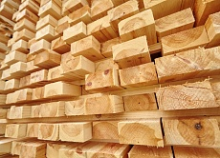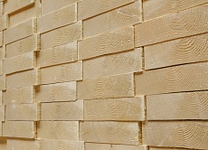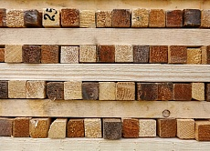

Kind of wood material:
- European spruce;
- pine;
- Angarsk pine;
- Siberian larch;
- Siberian spruce / fir;
- birch;
- cedar.
Industrial cut wood might have the natural humidity and 18% humidity.
Thickness 25mm +, width 100mm +, length 3000mm +, grade 1-2-3-4.

Quality:
All products follow the export and domestic standards: 26002-83 and 8486-86.

Shipment products by:
- freight transport (truck);
- rail transport;
- sea transport.

Packaging of industrial wood:
- polyethylene wrapping;
- packages with boards of the same length;
- separate packages.

Plywood
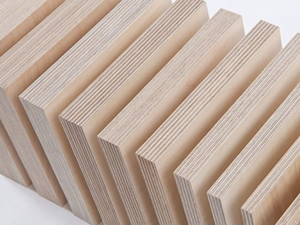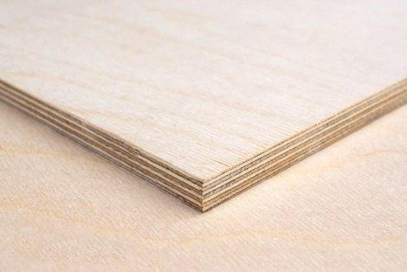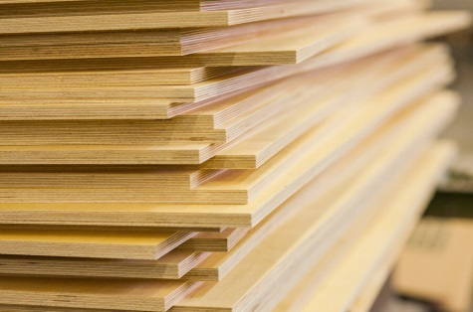

Kind of wood material:
- birch;
- oak;
- larch.

Surface type:
- Unpolished (NS);
- polished from 2 sides (S2S);
- laminated Smooth / Smooth (FF);
- Laminated Smooth / Mesh (FW).

Plywood thickness:
from 6mm to 40mm.

Shipment products by:
- freight transport (truck);
- rail transport;
- sea transport.

Fuel pellets
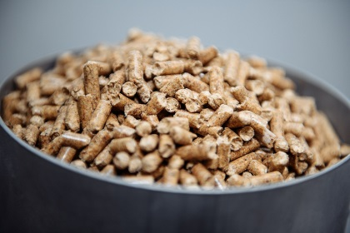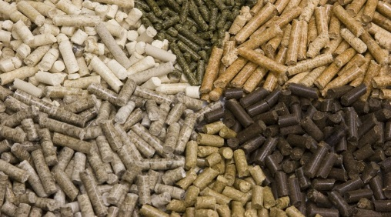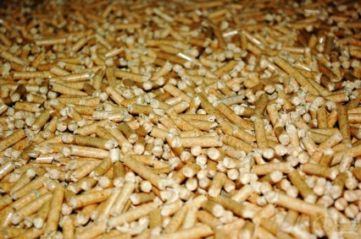

Composition of material:
70% Angarsk pine, 20% Siberian larch, 10% spruce / fir.

Follow to SBP and ENPlus A1 standards.

Pellet packing:
- big bags.

Shipment products by:
- freight transport (truck);
- rail transport;
- sea transport.
If you are interested of cooperation, we can supply various products from the following types of wood: pine, spruce, larch, birch, aspen, oak and others.
In additional we can supply the fuel pellets, plywood and other products according with your request. We have option to produce the goods according with your individual parameters.
We are ready to deliver the goods to any convenient place for you.
All our goods have the certificates of origin and the pass quality control. All prices and delivery terms of the each pitch of goods are individually discussed.
We look forward to long-term cooperation.
Tel. +7-917-524-55-10
E-mail: a.astafiev@frezart.ru
Skype: ast-uchet

CEO
«FRESART» LLC ________________ / Astafiev A.A.

